Introduction
Langerhans Cell Histiocytosis (LCH) is a rare blood disorder characterized by the abnormal proliferation and development of Langerhans Cells within the body (Badalian et al., 2012). Similar to cancer, these abnormal Langerhans Cells (LCs) accumulate in cellularly diverse tumor sites, potentially affecting bones, lymph nodes, and entire organ systems if left untreated. Affecting only 1 in every 200,000 children, very little is known about the cause of this life-threatening disease.
Regular Langerhans Cells (LCs) are dendritic cells found primarily in the skin, involved in the immunoregulatory process by presenting antigens to T cells (Valladeu et al., 2003). The LCs involved in LCH are phenotypically similar to regular LCs, but have several behaviors distinct from their healthy counterparts (da Costa et al, 2005.). On top of producing the typical LC protein of langerin, LCH cells produce unusually high levels of a range of cytokines, signaling molecules which interfere with the normal functioning of white blood cells within the body. Three key cytokines involved with LCH tumor behavior are described in Table A.
Table A. Key cytokines overproduced by LCH cells, encouraging cell proliferation and tumor development.
Interleukin-1α  (IL-1α)  Role:  Cytokine involved in the pro-inflammatory process, initiating immunity responses to foreign particles and inducing fevers. In LCH, these cytokines interact with T-cells found at the tumor site, stimulating their additional proliferation (Egeler et al., 1999). | Interferon-γ  (IFN-γ)  Role:  Anti-inflammatory cytokine involved with suppressing immune response. In LCH, the overproduction of this molecule in LCH cells is thought to prevent the full maturation of LCH cells, leaving them less developed than their healthy LC counterparts (Geissmann et al., 2001). | Granulocyte-macrophage colony-stimulating growth factor  (GM-CSF)  Role:  Cytokine that controls cellular growth and proliferation. In LCH, this cytokine is suggested to drive LCH cell development, resulting in invasive LCH cell growth and over replication at tumor sites (Emile et al., 1995).

This unusual behavior may be accounted for through the dysregulation of NF-κB (nuclear factor kappa-light-chain-enhancer of activated B cells) activity (Madonna et al., 2012). NF-κB is a protein complex responsible for regulating DNA transcription within animal cells (Hoesel & Schmid, 2013). Abnormalities in the genes relevant to this pathway have been linked to the formation of tumors. A similar mutation in the BRAF V600E gene has been discovered to widely occur in both melanoma and LCH patients, affecting the signaling cascade associated with the pathway (Badalian-Very, 2010). Documented over-activity in this cell-signaling pathway may be responsible for the overproduction of cytokines and the over proliferation of LCs characteristic of LCH. Because little is known about the origin of LCH cells, the root cause of this dysregulation in LCH cells remains unknown.
In order to determine what conditions lead to the development of LCH cells, it is vital to look at the origin of regular LCs. Regular LCs are typically self-dividing, but the body replenishes LCs in the event of major skin damage from bone marrow-derived cellular precursors. One proposed origin for regular LCs is through a differentiation pathway for monocyte CD14+, a blood cell with potential to mature into several cells associated with the immune system (Geissmann et al., 2005). In vitro, LC-like cells have been found to develop when adult monocyte CD14+ is grown in media containing cytokines associated with dendritic cell development (by name, TGFβ1, GM-CSF, and IL-4). The experiment performed by Geissmann et al. is described in Figure A.
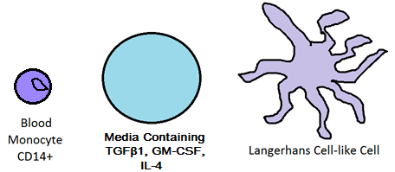

Figure A. Langerhans Cell origin through blood monocyte CD14+. Growing adult monocyte CD14+ in media containing TGFβ1, GM-CSF, and IL-4 result in its maturation into langerin producing, LC-like cells.

Given this proposed origin of regular Langerhans Cells, the question becomes whether the LCs involved in LCH follow the same differentiation pathway. Monocytes found in LCH tumor sites may develop into the abnormal LCs typical of LCH, explaining the formation of LC-rich tumors in locations LCs are usually not found. In this event, genetic abnormalities in monocyte CD14+ are likely the cause of LCH disease behavior. By discovering the origin of LCH cells, further studies could lead to the identification of potential tumor-causing genes that influence LCH cell signals, which holds practical implementation in the realm of developing better treatments for this disease.

Methods
In order to test this theory of LCH cell origin, LCH-afflicted and regular blood samples would need to be collected. Cell samples would be taken from the tumor site of an LCH patient, preliminary blood from the same patient, and a third sample from a healthy patient who does not have LCH. CD14+ monocytes would be collected through antigen tagging and centrifugation techniques described by Geissmann et al. All samples would be exposed to the same growth conditions defined in the same experiment, grown in a medium supplemented with IL-4, GM-CSF, and TGFβ1 to stimulate cell growth. Sample perimeters are described in Figure B.

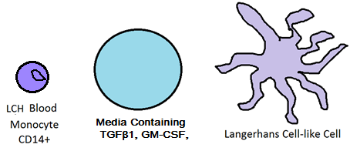

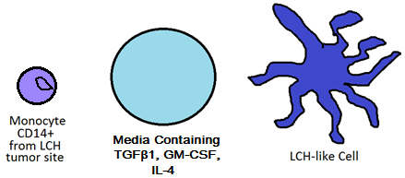

?

Figure B. Proposed Langerhans Cell Histiocytosis cell origin through monocyte CD14+ at the tumor site. Monocyte CD14+ will be isolated from an LCH tumor site, blood from the same LCH patient, and a control blood sample from a healthy, non-LCH afflicted patient. Each sample will be grown in media containing the same growth conditions initially described Figure A. The resulting differentiated cells will be measured for LCH-like behavior.

Once the three samples are grown in the same differentiated conditions, several markers of LCH-like cell behavior will be measured. The overproduction of cytokines that interfere with normal white blood cell processes will act as one such marker. LCH cells overproduce IL-1α, IFN-γ, and GM-CSF when compared to the normal LC counterparts; these cytokines assist in defining many characteristics of the disease, as described in Table A. In order to gauge the actual presence and production of these cytokines, antigen tagging can be utilized to isolate the target proteins, and the presence of RNA encoding these particular proteins will also be measured using PCR and liquid hybridization techniques (Enk & Katz, 1992).
Within an experiment conducted by Enk & Katz, the concentration of several RNA precursors for allergy-inducing target cytokines were measured (Enk & Katz, 1992). Similar techniques can be utilized for this experiment. A separate cell sample can be taken from all three differentiated monocyte samples described in Figure B. Centrifugation and a cesium chloride gradient will be utilized to isolate RNA from other cell products based on density. Once this is isolated, the overall concentration of the target RNAs coding the cytokines of interest in all three samples can be measured through PCR and liquid hybridization techniques.
Enk & Katz used Polymerase Chain Reaction (PCR) techniques in order to amplify mRNA levels of their target cytokines to a measurable concentration. Complementary DNA was reserve-transcribed from RNA utilizing pre-prepared primers alongside an enzyme known as Moloney murine leukemia virus reverse transcriptase. Once reverse-transcribed, target sequences from this complementary DNA were amplified via PCR. The primer sequences for cytokines IL-1α, IFN-γ, and GM-CSF have been pre-determined within experiments conducted by Enk & Katz as well as Halminen et al. and Yee et al. These primer sequences are complementary to the 3’ end of the nucleotide sequences encoding the target RNAs; the correct temperature during heating/cooling cycles of PCR allow the primers to bind onto the target sequences with great specificity. Between heating/cooling cycles, double-stranded DNA is broken in two, and primers bind onto the complementary DNA stands, allowing for replication of the target sequences. After several cycles of replication, the initial target sequences have been greatly amplified from their initial level, allowing for the measurement and quantification of the RNA concentration. PCR techniques are described in Figure C.
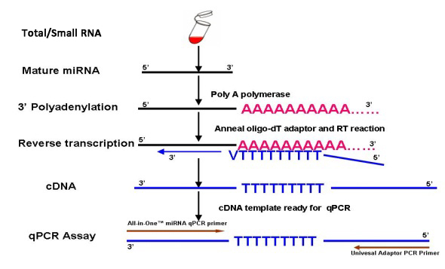
Figure C. RNA amplification via Polymerase Chain Reaction (PCR). Procedure involves: 1) RNA purification from other cell products via CsCl gradient. RNA stabilized through polyadenylation. 2) Total RNA reverse transcribed using enzyme Moloney murine leukemia reverse transcriptase. 3) Target cDNA found in PCR cycles via primer sequences. Primer sequences for cytokines IL-1α, IFN-γ, and GM-CSF are available on GenBank. DNA is synthesized as initiated by the primer sequences. 4) Heating/cooling cycles break apart strands and continue to synthesize cDNA between heat cycles, amplifying initial RNA products.

The amplified RNA products of PCR can be measured through liquid hybridization techniques described by Enk & Katz. The amplified RNA products can bind with complementary probes labeled by radioactive isotope phosphorous-32. The tagged samples can then undergo electrophoresis in order to measure the nucleotide content in each sample through each sequences’ relative size; from this, we can separate and identify the target RNAs from each other. The samples can be added to prepared PAGE gel and an electric current can be sent through it in order to disperse the contents across the gel as described in Figure D. Once the RNAs are identified, quantitative analysis via software and scanners compare the RNA concentrations across the three cell samples and generate phosphorous-32 signal strength comparisons like those found in Figure E. The computer-generated graphs measuring the radioactivity can be used to compare the cytokine concentrations within our three samples.

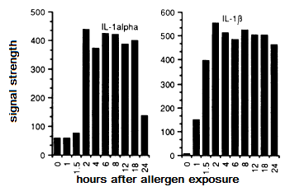
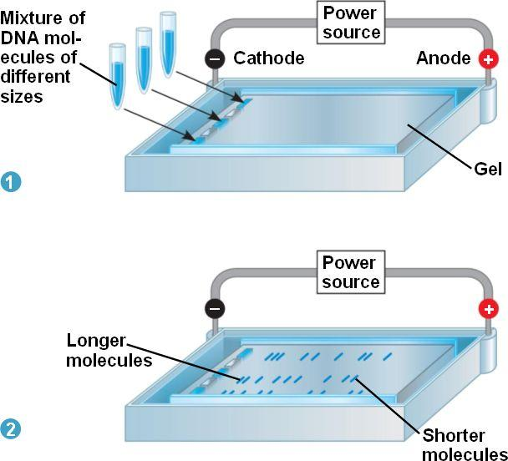
Discussion
Figure D. Electrophoresis of amplified RNA products will be performed on phosphorous-32 and non-phosphorous-32 labeled samples. With an electric current added, DNA moves towards the negatively charged end of the gel. RNA content can be identified based on the relative size of the sequences. Image provided via Pearson Biology Online.
Figure E. RNA signal strength versus time, as pictured in Enk & Katz. Densitometric scanning is used to measure the levels of radioactive phosphorous-32 present in the RNA probes, indicating the amount of RNA in each given sample. These computer-calculated graphs are similar to what will be produced within our own experiment, with the x-axis instead indicating sample origins from a LCH tumor site, a LCH patient’s blood, and a healthy patient’s blood.
The first question that will be uncovered within this experiment is whether or not the monocyte-dependent differentiation pathway theorized for regular LCs is even relevant in abnormal LCH cells. That is, is it possible for LCH cells to be derived from the exact same conditions as LCs in vitro? In the event that they are not, then one possible origin for regular or irregular LCs can be ruled out. Further experimentation for other proposed LC differentiation origins via different monocytes can be tested using the same procedures described in this experiment, potentially suggesting the in vivo origin of regular LCs. Otherwise, it can be assumed there are no differences within the monocyte precursors in LCH cells, indicating non-myeloid environmental causes for the development of the disease.
Further data might be drawn as it pertains to the differentiation of regular LCs as a result of this experiment. If LCH-like cells are derived from like conditions, then this further suggests the monocyte CD14+ is involved in initial production of LCs. This has application within the field of autoimmune research; LCs are involved in the body’s first response to HIV and other like viruses, and knowledge of how to replenish the body’s supply might help in treatment of the disease. Of course, in vitro results should not always be extrapolated as true in vivo, but this study serves as a jumping off point for further investigation.
Of greatest interest, however, is what a positive result might mean for discovering the genetic and cellular origin of LCH. If LCH-like cells can be derived from CD14+ monocytes, then genomic differences in monocytes within the tumor site are likely accountable for this altered differentiation results. DNA sequencing of both monocyte samples from the tumor and preliminary blood of the LCH patient could be pursued to document these differences. Fearon & Vogelstein conducted a similar study with colon cells from tumor and nontumorous sites, identifying potential oncogenes involved in the development of colon cancer (Fearon & Vogelstein, 1990). Those techniques might be utilized for this follow-up study.

References
Badalian-very G, Vergilio JA, Degar BA, Rodriguez-galindo C, Rollins BJ. Recent advances in the understanding of Langerhans cell histiocytosis. Br J Haematol. 2012;156(2):163-72.
Badalian-Very, Gayane et al. “Recurrent BRAF Mutations in Langerhans Cell Histiocytosis.” Blood 116.11 (2010): 1919–1923. PMC.
da Costa, Cristiana E.T., Nicola E. Annels, and R. Maarten Egeler. "The immunological basis of Langerhans cell histiocytosis", Histiocytic Disorders of Children and Adults. Ed. Sheila Weitzman and R. Maarten Egeler. 1st ed. Cambridge: Cambridge University Press, 2005. pp. 66-82. Cambridge Books Online.

Egeler RM, Favara BE, Van meurs M, Laman JD, Claassen E. Differential In situ cytokine profiles of Langerhans-like cells and T cells in Langerhans cell histiocytosis: abundant expression of cytokines relevant to disease and treatment. Blood. 1999;94(12):4195-201.

Emile JF, Fraitag S, Andry P, Leborgne M, Lellouch-tubiana A, Brousse N. Expression of GM-CSF receptor by Langerhans' cell histiocytosis cells. Virchows Arch. 1995;427(2):125-9.

Enk, A.H., Katz, S.I.(1992).Early molecular events in the induction phase of contact sensitivity. Proc. Natl. Acad. Sci. USA,89, 1398-1402.

Fearon ER, Vogelstein B. A genetic model for colorectal tumorigenesis. Cell. 1990;61(5):759-67.

Geissmann F, Lepelletier Y, Fraitag S, et al. Differentiation of Langerhans cells in Langerhans cell histiocytosis. Blood. 2001;97(5):1241-8.

Geissmann F, Prost C, Monnet JP, Dy M, Brousse N, Hermine O. Transforming growth factor beta1, in the presence of granulocyte/macrophage colony-stimulating factor and interleukin 4, induces differentiation of human peripheral blood monocytes into dendritic Langerhans cells. J Exp Med. 1998;187(6):961-6.

Halminen M, Sjöroos M, Mäkelä MJ, et al. Simultaneous detection of IFN-gamma and IL-4 mRNAs using RT-PCR and time-resolved fluorometry. Cytokine. 1999;11(1):87-93.

Hayworth, Douglas. Overview of ELISA. 2014. Web. http://www.piercenet.com/method/overview-elisa

Hoesel B, Schmid JA. The complexity of NF-κB signaling in inflammation and cancer. Mol Cancer. 2013;12:86.

Madonna G, Ullman CD, Gentilcore G, Palmieri G, Ascierto PA. NF-κB as potential target in the treatment of melanoma. J Transl Med. 2012;10:53.

Rizzo FM, Cives M, Simone V, Silvestris F. New insights into the molecular pathogenesis of langerhans cell histiocytosis. Oncologist. 2014;19(2):151-63.
Valladeau, Jenny; Dezutter-Dambuyant, Colette; Saeland, Sem (2003). "Langerin/CD207 Sheds Light on Formation of Birbeck Granules and Their Possible Function in Langerhans Cells". Immunologic Research 28 (2): 93–107.
Yee CS, Yao Y, Xu Q, et al. Enhanced production of IL-10 by dendritic cells deficient in CIITA. J Immunol. 2005;174(3):1222-9.

